Platform Migration

🌟 Definition
# Source: AI Source: Provided by: [Data Path: Persons Table -> ID Column: 1, Name_En Column: Motasem Essam] -> From: [ChatGPT] on [6/7/2026]
Platform Migration is the process of moving an application from one platform to another platform while preserving its core functionality.
A platform can be:
- Desktop
- Web
- Mobile
- Operating System
- Cloud Platform
- Runtime Environment

🎯 Purpose
# Source: AI Source: Provided by: [Data Path: Persons Table -> ID Column: 1, Name_En Column: Motasem Essam] -> From: [ChatGPT] on [6/7/2026]
Platform migration is performed to:
- Reach more users
- Improve accessibility
- Modernize applications
- Reduce maintenance costs
- Improve scalability
- Support new technologies

🧠 Simple Definition
# Source: AI Source: Provided by: [Data Path: Persons Table -> ID Column: 1, Name_En Column: Motasem Essam] -> From: [ChatGPT] on [6/7/2026]
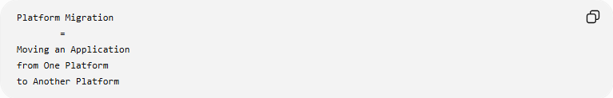
Platform Migration
=
Moving an Application
from One Platform
to Another Platform

📚 What is a Platform?
# Source: AI Source: Provided by: [Data Path: Persons Table -> ID Column: 1, Name_En Column: Motasem Essam] -> From: [ChatGPT] on [6/7/2026]
A platform is the environment where an application runs.
Examples:
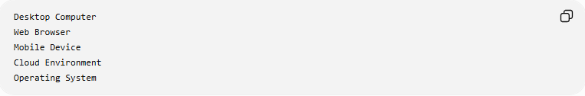
Desktop Computer
Web Browser
Mobile Device
Cloud Environment
Operating System

🔍 Common Types of Platform Migration

1️⃣ Desktop-to-Web Migration
# Source: AI Source: Provided by: [Data Path: Persons Table -> ID Column: 1, Name_En Column: Motasem Essam] -> From: [ChatGPT] on [6/7/2026]
Move a desktop application to a web application.
Before
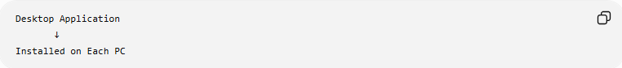
Desktop Application
↓
Installed on Each PC

After
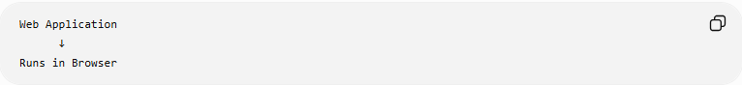
Web Application
↓
Runs in Browser

Example
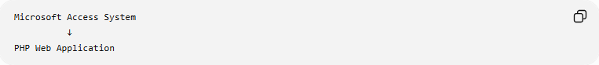
Microsoft Access System
↓
PHP Web Application
Benefits:
- Multi-user access
- Remote access
- Easier updates

2️⃣ Desktop-to-Mobile Migration
# Source: AI Source: Provided by: [Data Path: Persons Table -> ID Column: 1, Name_En Column: Motasem Essam] -> From: [ChatGPT] on [6/7/2026]
Move an application to mobile devices.
Before
Desktop Software

After
Android App
iOS App

Example:
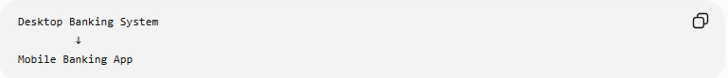
Desktop Banking System
↓
Mobile Banking App
Benefits:
- Mobility
- Better user engagement

3️⃣ Web-to-Mobile Migration
# Source: AI Source: Provided by: [Data Path: Persons Table -> ID Column: 1, Name_En Column: Motasem Essam] -> From: [ChatGPT] on [6/7/2026]
Create a mobile version of an existing web application.
Before
Website

After
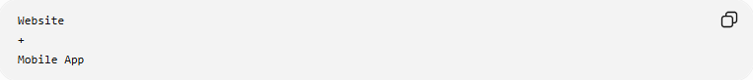
Website
+
Mobile App

Example:
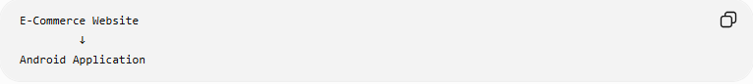
E-Commerce Website
↓
Android Application

4️⃣ On-Premises-to-Cloud Migration
# Source: AI Source: Provided by: [Data Path: Persons Table -> ID Column: 1, Name_En Column: Motasem Essam] -> From: [ChatGPT] on [6/7/2026]
Move applications to cloud platforms.
Before
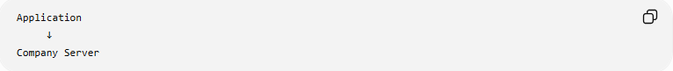
Application
↓
Company Server

After
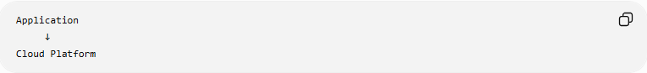
Application
↓
Cloud Platform
Examples:
- Amazon Web Services
- Microsoft
- Google

Benefits:
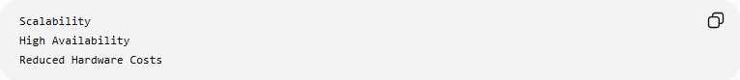
Scalability
High Availability
Reduced Hardware Costs

5️⃣ Operating System Platform Migration
# Source: AI Source: Provided by: [Data Path: Persons Table -> ID Column: 1, Name_En Column: Motasem Essam] -> From: [ChatGPT] on [6/7/2026]
Move applications between operating systems.
Example
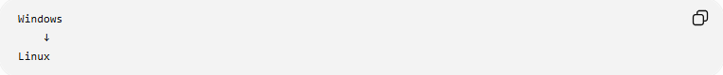
Windows
↓
Linux
or
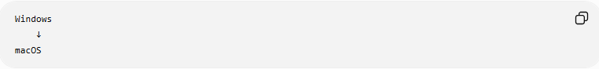
Windows
↓
macOS

Benefits:
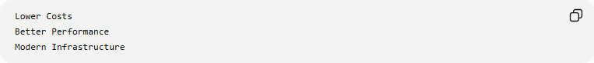
Lower Costs
Better Performance
Modern Infrastructure

🛠️ Real-World Example
# Source: AI Source: Provided by: [Data Path: Persons Table -> ID Column: 1, Name_En Column: Motasem Essam] -> From: [ChatGPT] on [6/7/2026]
Before Migration
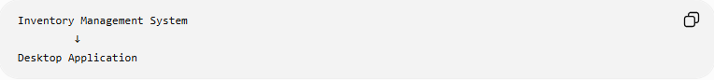
Inventory Management System
↓
Desktop Application
Problems:
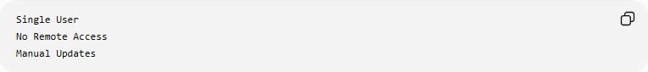
Single User
No Remote Access
Manual Updates

Platform Migration
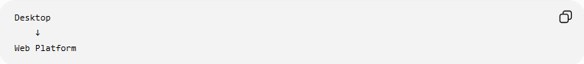
Desktop
↓
Web Platform

After Migration
Inventory Management Website
Benefits:
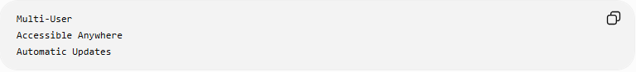
Multi-User
Accessible Anywhere
Automatic Updates

🔄 Platform Migration Lifecycle
# Source: AI Source: Provided by: [Data Path: Persons Table -> ID Column: 1, Name_En Column: Motasem Essam] -> From: [ChatGPT] on [6/7/2026]
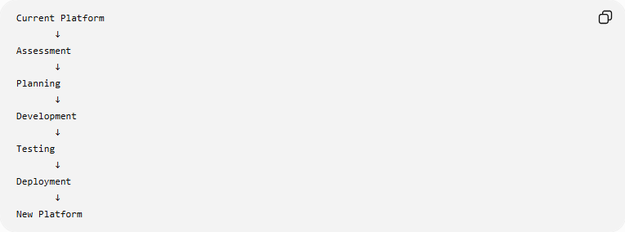
Current Platform
↓
Assessment
↓
Planning
↓
Development
↓
Testing
↓
Deployment
↓
New Platform

📦 Common Migration Activities
# Source: AI Source: Provided by: [Data Path: Persons Table -> ID Column: 1, Name_En Column: Motasem Essam] -> From: [ChatGPT] on [6/7/2026]
User Interface Migration
Before
Desktop UI

After
Web UI
Mobile UI

Database Connection Updates
Before
Local Database

After
Cloud Database

Authentication Updates
Before
Local Login

After
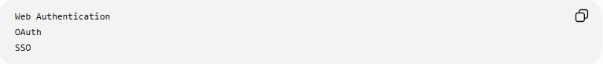
Web Authentication
OAuth
SSO

Deployment Changes
Before
Install on Every Computer

After
Deploy Once to Server

🌍 Real-World Examples
# Source: AI Source: Provided by: [Data Path: Persons Table -> ID Column: 1, Name_En Column: Motasem Essam] -> From: [ChatGPT] on [6/7/2026]
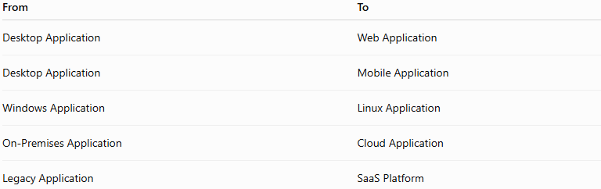
From | To
Desktop Application | Web Application
Desktop Application | Mobile Application
Windows Application | Linux Application
On-Premises Application | Cloud Application
Legacy Application | SaaS Platform

⚠️ Challenges
# Source: AI Source: Provided by: [Data Path: Persons Table -> ID Column: 1, Name_En Column: Motasem Essam] -> From: [ChatGPT] on [6/7/2026]
Possible issues:
- User interface redesign
- Compatibility problems
- Performance differences
- User training
- Security updates
- Data synchronization issues

✅ Benefits
# Source: AI Source: Provided by: [Data Path: Persons Table -> ID Column: 1, Name_En Column: Motasem Essam] -> From: [ChatGPT] on [6/7/2026]
Better Accessibility
Anywhere
Any Device

Easier Maintenance
One Deployment
Many Users

Scalability
More Users
More Resources

Modern User Experience
Responsive Design
Mobile Support

📊 Platform Migration vs Framework Migration
# Source: AI Source: Provided by: [Data Path: Persons Table -> ID Column: 1, Name_En Column: Motasem Essam] -> From: [ChatGPT] on [6/7/2026]
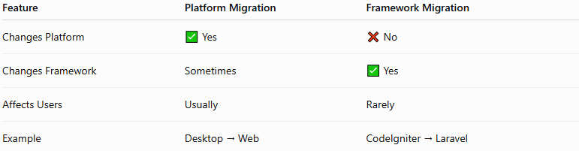
Feature | Platform Migration | Framework Migration
Changes Platform | ✅ Yes | ❌ No
Changes Framework | Sometimes | ✅ Yes
Affects Users | Usually | Rarely
Example | Desktop → Web | CodeIgniter → Laravel

Platform Migration Example
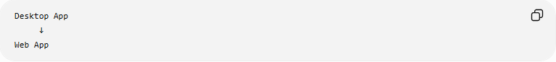
Desktop App
↓
Web App

Framework Migration Example
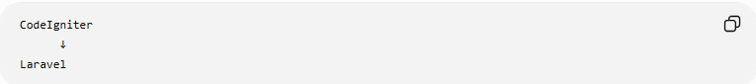
CodeIgniter
↓
Laravel
Application remains a web application.

🛠️ Common Technologies Used
# Source: AI Source: Provided by: [Data Path: Persons Table -> ID Column: 1, Name_En Column: Motasem Essam] -> From: [ChatGPT] on [6/7/2026]
Web Platforms
- Apache HTTP Server
- Nginx
Mobile Platforms
- Android
- iOS
Cloud Platforms
- Amazon Web Services
- Microsoft
- Google

🧠 Simple Analogy
# Source: AI Source: Provided by: [Data Path: Persons Table -> ID Column: 1, Name_En Column: Motasem Essam] -> From: [ChatGPT] on [6/7/2026]
Imagine a store.
Before
Physical Store Only

Migration
Create Online Store
Move Products Online

After
Online Store
The business is the same, but it now operates on a different platform.
Platform migration works similarly:
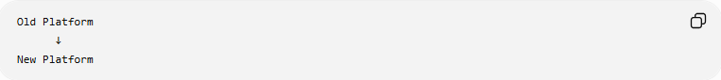
Old Platform
↓
New Platform
while keeping the application's main purpose intact.

🧭 Summary
# Source: AI Source: Provided by: [Data Path: Persons Table -> ID Column: 1, Name_En Column: Motasem Essam] -> From: [ChatGPT] on [6/7/2026]
Platform Migration is a type of application migration where software is moved from one platform to another, such as Desktop → Web, Desktop → Mobile, Windows → Linux, or On-Premises → Cloud. The goal is to improve accessibility, scalability, maintainability, and user experience while preserving the application's core functionality.

